eMunicipality of Bar

Sanja Stanišić
Advisor to the Mayor of Bar for International and Public Relations
Montenegro
sanja.stanisic@bar.me

Abstract
The eMunicipality of Bar is an integrated information system which enables more efficient, responsive and transparent operations of the local administration. It speeds up work processes, makes databases easily accessible and makes file processing and management easier.
The integrated information system implies that the entire file and document processing is automated. Hard copies are stored only in the Citizen’s Bureau which operates as a one-stop shop. Various documents produced upon completion of file/document processing (e.g. permits, licenses, notices of rejection or acceptance) are automatically stored in appropriate electronic registers.
Citizens are able to obtain quickly and easily information relating to the status of their requests or documents under processing, while authorized staff can easily oversee the performance of each employee/department, and supervise file/document processing.
The eMunicipality also enables automated management and control of the tax-paying system, public procurements, investments, as well as human resources and finance management. It also includes databases relating to all areas of municipal operations.

Project background
The Municipality of Bar is one of 21 Montenegrin municipalities. It has a favourable geographical position: situated in the southern part of the country, Bar represents a marine gateway to Montenegro and an important economic centre. Tourism is the priority economic sector, since there are excellent resources for development of this industry:- it includes 45 km of Adriatic coast, 9.5 km of which are sandy beaches; 67 km of Lake Skadar’s shore, a rich cultural heritage and good sports facilities. Bar has 43 000 inhabitants and it is 4th most populated municipality in Montenegro. However, over the summer tourist season the population more than doubles.
Due to the number of inhabitants and temporary residents, as well as the number of companies operating in Bar (10% of the total number of companies in Montenegro), the Municipality of Bar has a relatively high number of employees (280) working in six departments: the Agency for Investment and Real Estate, the Economic and Finance Department, Department of Urban Planning, Housing and Environmental Protection, Department for Social and General Affairs, Fire Department and Municipal Police Department.
The municipality, despite being considered one of the most developed in the country and a leader in innovations in terms of the usage of new technologies, has faced the same problems that many other municipalities worldwide have been facing – insufficient efficiency and transparency. Therefore, the intent of the municipal authorities was to create a more efficient administration and business-enabling environment, i.e. to improve delivery of services, provide full transparency of work processes and reduce business barriers by applying state-of-the-art information and communication technologies (ICTs).
In order to achieve these goals the Municipality of Bar simultaneously implemented two projects: a guillotine review of regulations and eMunicipality.
The guillotine review of regulations is an orderly and transparent process of counting and then rapidly reviewing regulations against clear criteria, and eliminating those that are no longer needed. The goal of this of this process is to reduce business barriers. i.e. create a business enabling environment and stimulate economic growth. As a result of the guillotine review municipal administrative procedures were shortened and simplified and a registry containing all formalities and procedures (including all relevant data such as legal basis, responsible person, deadlines for a certain formality/procedure) was made available to citizens/clients.
Subsequently the eMunicipality project was implemented, and it was performed in two stages. Firstly, throughout 2008 the computer equipment was procured and the IT communication network configured. By mid 2009 the first version of software application was delivered and put in use.
The total value of the project, including both hardware and software component, amounted to circa € 280 000.
At the moment the municipality is the only one in Montenegro to have completely automated its work processes and gathered into one place all the information necessary for smooth operation of the local administration. The Union of Municipalities of Montenegro recognised eMunicipality of Bar in November 2010 as a best practice in the introduction of ICTs in service delivery.

Project objectives
The eMunicipality project was aimed at improving the services and the operations of Bar’s local administration. Obviously, the implementation of eGovernment projects at all levels is not a single event, but rather a long-term process of transforming the government to focus on citizens’ services.
Therefore, the initial focus was on creating a paperless government and improving the quality of services, efficiency and transparency of work processes. Namely, to simplify document management and processing procedures, increase responsiveness and accountability of the local administration through the usage of ICTs. The goal was also to enable citizens to obtain quickly and easily information relating to the status of their requests or documents under processing.
In addition, it was necessary to enable local government and heads of departments to obtain in a short time full information regarding the status of all documents under processing and activities undertaken towards their completion.
Since there were legacy systems in some of the departments, it was necessary to create an efficient and functional integrated information system which would enable automated management and control of the tax-paying system and tax payers, public procurements, investments, municipal properties, as well as human resource and finance management.
The goal of eMunicipalty was also to create good quality databases relating to all areas of municipal operations, such as: non-governmental organisations (NGOs), cultural and sports organisations and events, the education system, etc.
The application of this integrated information system implies that file and document processing is entirely automated. In the Citizen’s Bureau, which operates as a one-stop shop, all documents are scanned and attached to the corresponding files. The same happens with the documents arriving through the web portal. The hard copies are stored in the Citizen’s Bureau only, and the processing is entirely automated.
At the very moment a client submits a request and the Citizen’s Bureau make a record of the file, attaching all the corresponding documents as scanned copies, the head of the competent department is able to forward the file to his/her employees for processing and follow up the entire procedure. They can check the file status at any time by logging onto the eMunicipality system using their user names and passwords.
The employees can search the files assigned to them using various criteria. They are automatically informed of the arrival of new documents relating to the files they are processing.
Authorized persons can easily check the status of files at a certain point in time and determine the performance of each employee, as well as each department.
The various documents produced upon completion of file processing (e.g. permits, licenses, notices of rejection or acceptance) are automatically stored in the appropriate registers.
Figure n.1: Workflow Diagram

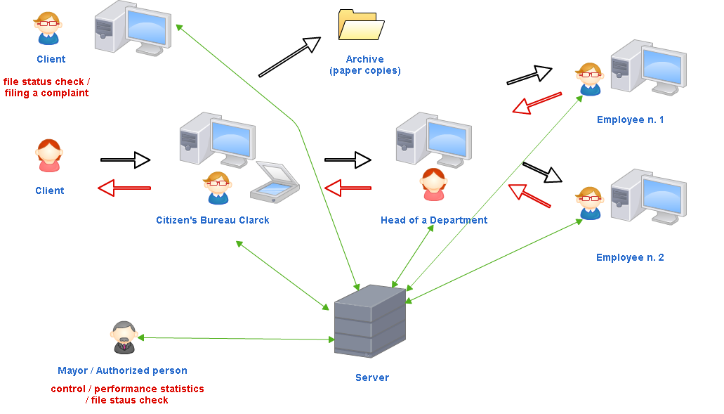

Technology used
The software application was tailor-made to satisfy the specific needs of the Municipality of Bar. It was developed in the C# programming language, under the .NET framework 3.5. Microsoft SQL Server 2005, Enterprise edition, was used as a database management system, while Microsoft Internet Information Server acts as the web server.
16 servers were procured in order to provide smooth operation of the entire integrated information system. Database and web servers were configured in clusters to be able to continue to operate even in the event of some of them having a systems failure.
Uninterrupted power suppliers (UPSs keep the system in function for a certain period of time in case of a power failure. A generator unit was also procured to serve as an alternative power supply in case of long duration power outage.
All data within the eMunicipality system is copied regularly, and one copy is saved outside the municipal premises so they can be easily restored even in case of a complete systems failure.
There were legacy systems in some of the departments, and the new software application provided full integration, i.e. complete data transfer from legacy systems was enabled in order to secure a functional and efficient fully integrated information system within the municipality.
While the first version of the software application was being tested and corrected, staff training sessions were organised on a “1-to-1” basis –meaning that every employee was trained at his/her working place. The trainers introduced every employee with the operations they are allowed / in charge of performing within this information system. The employees were provided as well with handbooks covering all the operations they had to master.
The cost of the development of the software application, which included also staff training, amounted to circa € 170 000.

Project development and implementation methodology use

The eMunicipality project was implemented in two stages:
- Procurement of computer equipment and configuration of IT infrastructure
- Software development

Both stages were preceded by preparation of adequate design and project documentation. The implementation of the project was supervised by the municipal working team led by the Chief Administrator.
The software was developed using an agile approach, as it was customized to the needs of Bar Municipality and it was impossible to determine in advance all the requirements of the application. The developers needed to have regular contact with municipal staff as their feedback was of utmost importance. The customized software was chosen for several reasons: since the Government of Montenegro had signed the license agreement with Microsoft, we didn’t have any additional costs for using Microsoft’s database management and internet servers. Besides, at the time of the software application development, the developers had considered Microsoft’s servers safer then open source ones.

Lessons learned and conclusions
Project experience has shown that in order to be able to successfully implement this kind of project, decision makers, with power and authority to impose a decision/solution in case of a problem, must be from among members of the municipal working team, besides IT personnel.
As a result of the guillotine review of regulations we had a registry of all municipal administrative procedures/formalities, which contained all the relevant data (e.g. what documents are needed for the issuance of a formality, who is responsible, what is the time limit) prepared before the start of the eMunicipality project. This registry enabled the developers to work more quickly, and it prevented manipulation by staff.
The major problems encountered during the project implementation were insufficient computer literacy and obstructions to the usage of the system which one part of the staff and middle management carried out in order to prevent full transparency of their work and efficiency. While the first one was easy to solve organizing several ECDL (European Computer Driving License) courses, we are still dealing with different kind of resistance to the usage of this information system.

NOTE: The full potential and benefits of the eMunicipality project cannot be realised until the Law on eSignature is fully applied in Montenegro and the municipality is legally allowed to issue electronic documents.

